**AIM:** Design TM using simulator to accept the input string wcw

**INPUT:**

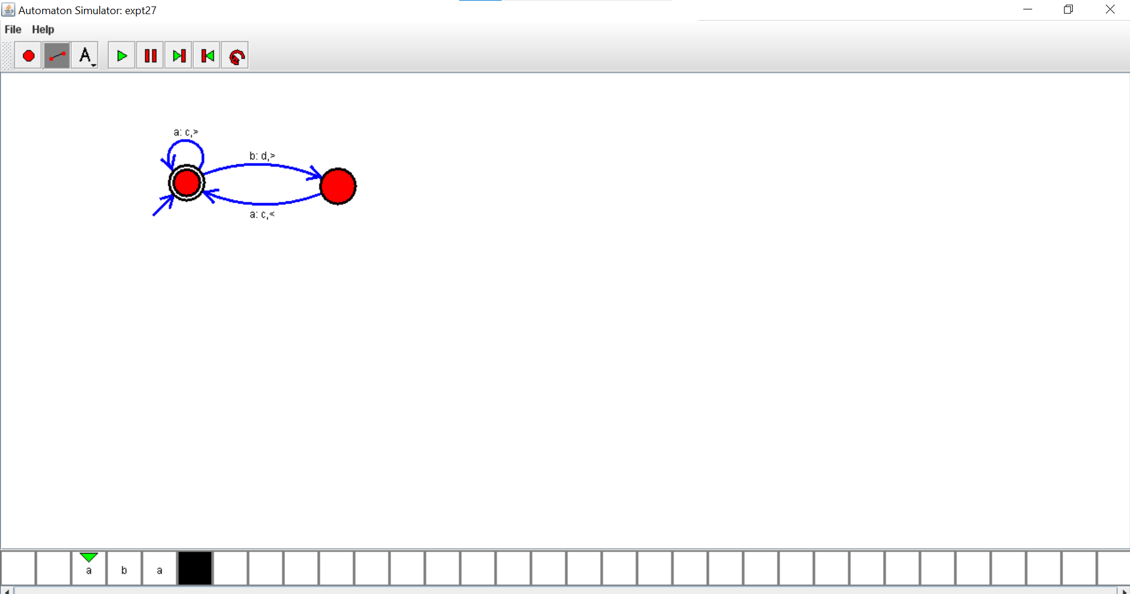

**OUTPUT:**

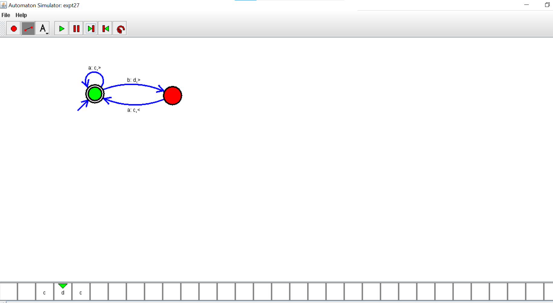

**RESULTS:** thus designed TM using simulator to accept the input string wcw